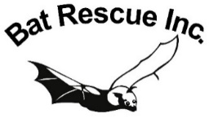
MEMBER NAME
Equipment Location (Address)

The following Bat Rescue Inc. equipment has been issued to me on the understanding that:
- It will be used for the purpose for which it was loaned
- It will remain in my custody/on my property
- All reasonable care will be taken to store and safeguard the equipment
- I will update Bat Rescue of the equipment’s condition and advise if it needs repair or replacement
- The equipment remains the property of Bat Rescue Inc. and will be returned to the organisation if/when my membership ceases, or if/when Bat Rescue needs to reallocate it

EQUIPMENT ITEMS
DATE RECEIVED | BRAND OR REF. NO (if any) | ITEM | DESCRIPTION | CONDITION  (Good/Fair/Poor) | NOTES

SIGNATURE
DATE
V2 Sept.2021

You may type your name if submitting via email and are unable to print and scan. Send your completed form either
via post to the address below, or scan/photograph and email to admin@batrescue.org.au.

